Steganography – Hiding Data in ‘plain’ sight
Data can be hidden in many ways. A quick & effective method is embedding data into an image. This activity is designed to give you some experience with Steganography.
Appending text to an image:
On your Windows 10 VMs, one simple method is to combine an image file and a text file into a bigger file.
- Find a small image on the Internet, open it in MS Paint & then save it as a 24bit bitmap (bmp) named image.
  - Record the file size. 293 KB
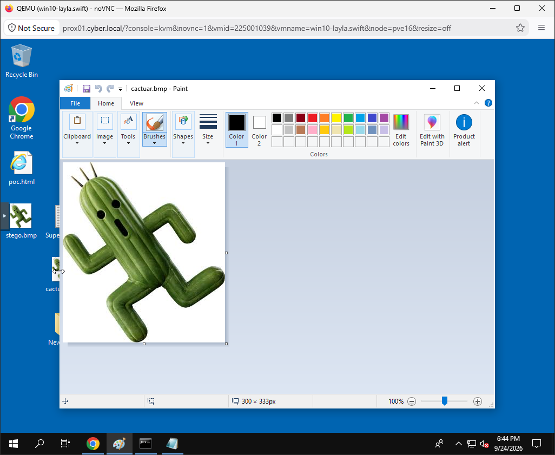
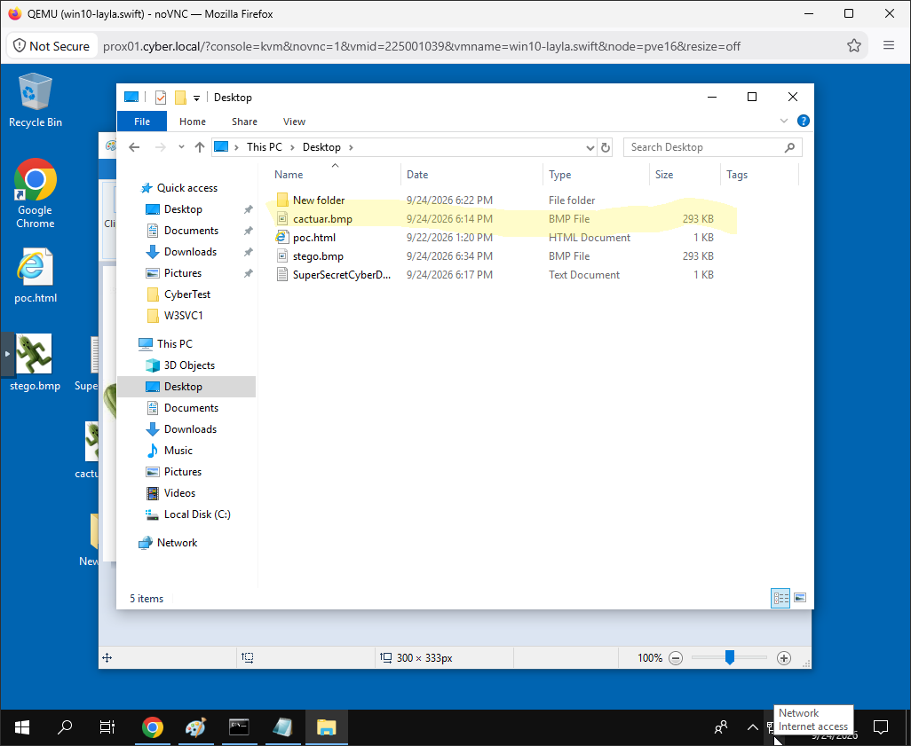
- Using Notepad, create a file called ‘SuperSecretCyberData’, and then insert “Passwords are yummy!”
  - What is the file size? 1 KB
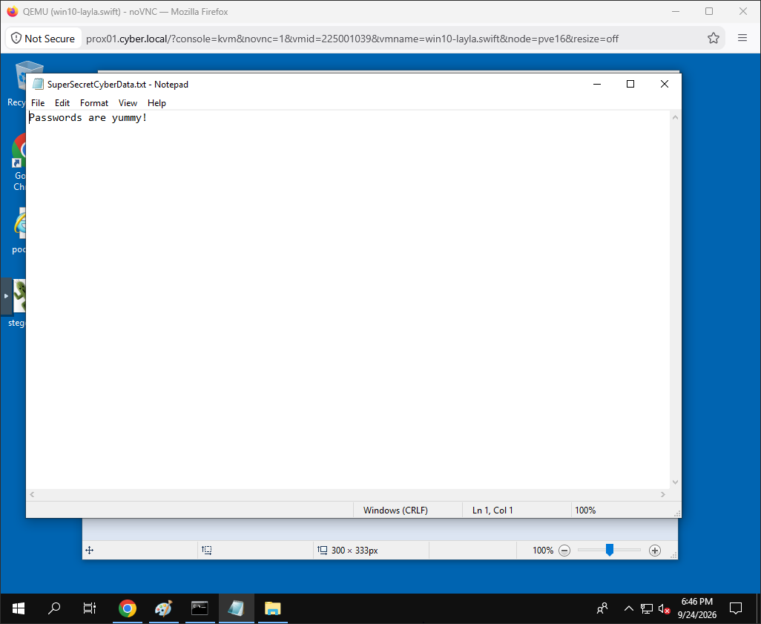
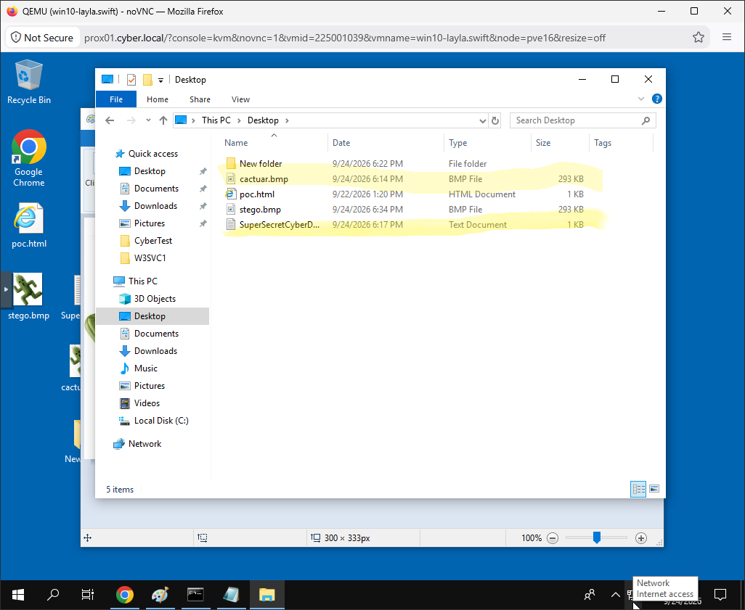
- Open a CMD window & combine the two file using the copy command.
  - Pro Tip: This uses the /b , binary option and + for joining files.
  - copy /b image.bmp + SuperSecretCyberData.txt stego.bmp
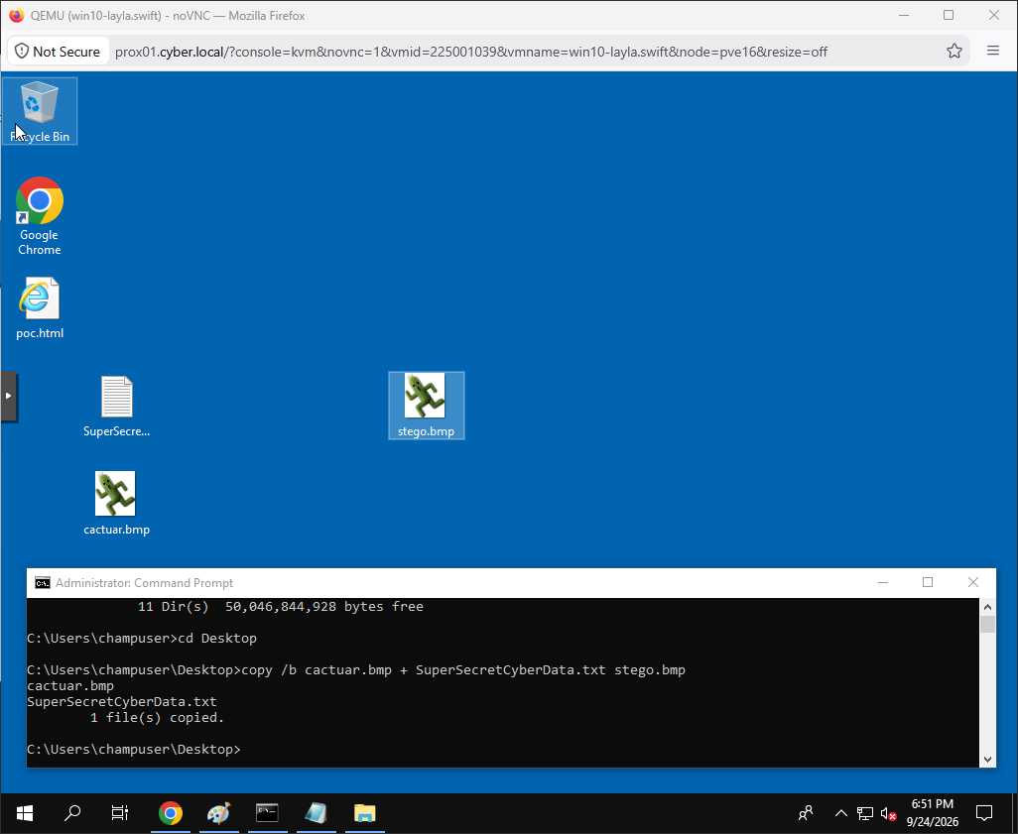
- Open stego.bmp with MS Paint (don’t judge). You should still see the image.
- Open it with Notepad, and at the bottom/end is your message.
  - It is messy with the bmp encoding, but it is there.
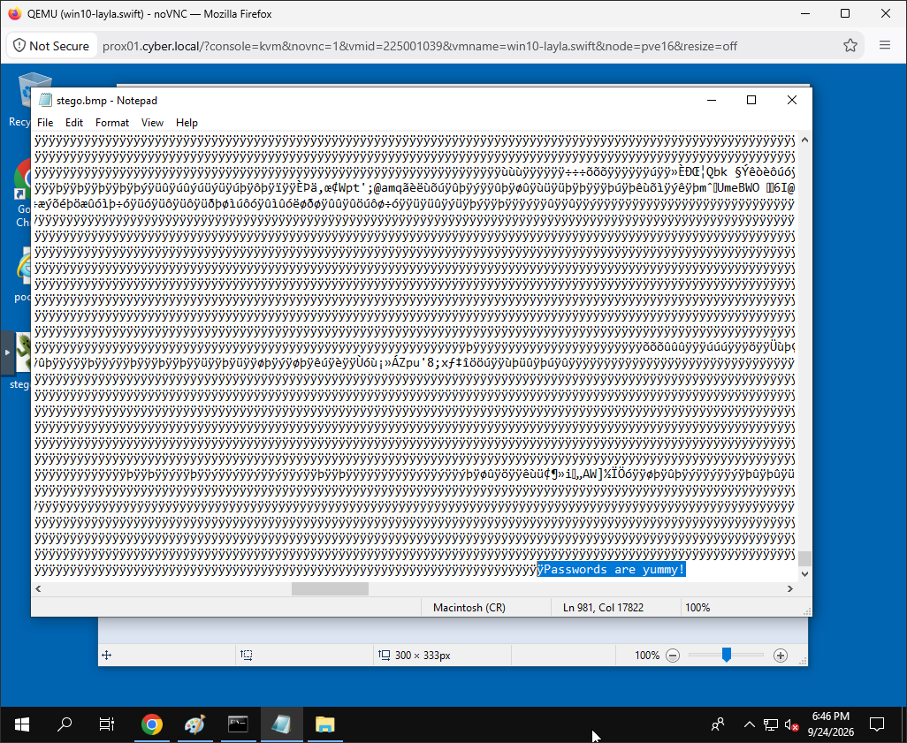

Thus hides your message inside the image file. However, the text is still visible in its normal form.
What is the file size of stego.bmp? 293 KB
How much has the file size changed from image.bmp? 0 KB
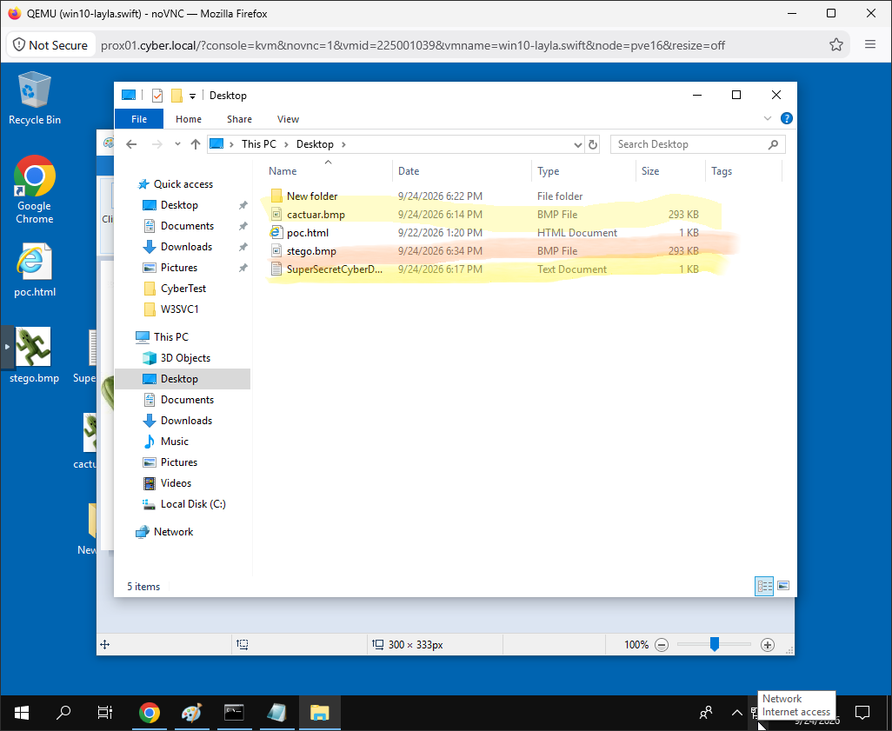
Submit answers & snips of your successful results via Canvas.

